Introduction:

1. Binary notation is in zeroes and ones.
2. Unary notation is essentially only ones, like counting on your fingers.
3. Example: 1 = 1, 2 = 1 + 1, 3 = 1 + 1 + 1 etc.
4. With one hand, we can count upto 32, i.e, from 0 1o 31. Also, 2 ^ 5 is 32, so every finger represents 2 states.
5. Base 1 uses “one finger”, Base 2 uses “two fingers”
6. Computers use base 2, aka binary
7. Bit = Binary Digit
8. Transistors are responsible for storing and dissipating electricity, i.e for representing 1’s and 0’s
9. Base 10 system is called decimal system
10. 1 byte = 8 bits

ASCII:

1. A is represented by the number 65
2. With eight bits, we can represent 2 ^ 8 alphabets, which is 256
3. 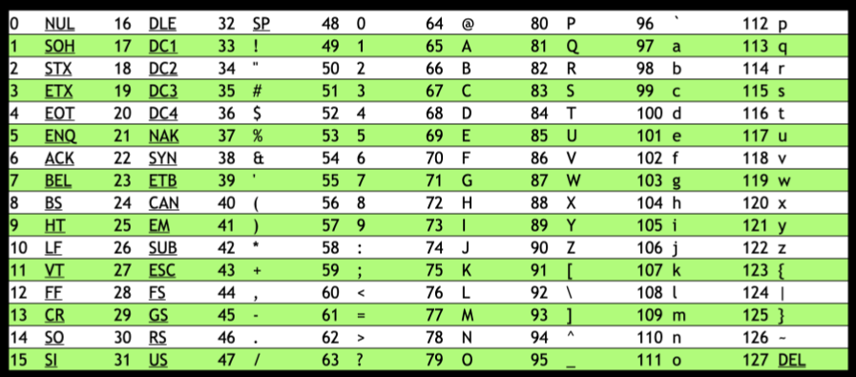
4. Emojis are also represented using 0’s and 1’s, and have their own numerical values like the ASCII table above.
5. Unicode is a superset of ASCII. Emojis use Unicode for representation. With Unicode, we can represent upto 2 ^ 32 characters = approx. 4 billion. Unicode goes up to 4 bytes.
6. For example, the unicode for a generic thumbs up is U+1F44D. It starts with U+, but that’s only for us to understand that the value that’s coming is in Unicode. Also, Unicode values can have letters in between.

RGB:

1. We use RGB because depending on how much Red Green and blue we use, we can generate any colour.
2. The numbers 72 73 33 would convert to “Hi!”, but it would also give you the colour yellow. Therefore, depending on context, the numbers would mean different things.
3. Every pixel is of 3 bytes(RGB).
4. Music is represented using MIDI. One number may represent the note, the next may represent the duration, one number may represent the sharpness etc.

Algorithm:

1. Code is just the implementation of algorithms
2. Pseudocode is just one step away from actual code.
3. If and else…if are called conditionals
4. True or false statements are called Boolean expressions. Example: while loop and for loop.

Artificial Intelligence:

1. LLM’s = Large Language Models
2. The input of LLM’s is Language. By that, it is essentially fed data from massive amounts of web pages, Wikipedia articles, news articles etc. The output that we end up receiving is actually what the model thinks is the most likely response a human would give to the question asked. It’s not necessarily correct, but it is the most human.
3. Examples: We provide the question “How are you?”  
    The model checks the data it has, and calculates with 90% probability that the most appropriate response to this is “I’m good. How about you?”

Scratch and extra notes:

1. A return value is a value that you receive from a function, that you can do something with.